1.. <http://localhost:4433/phpmyadmin>

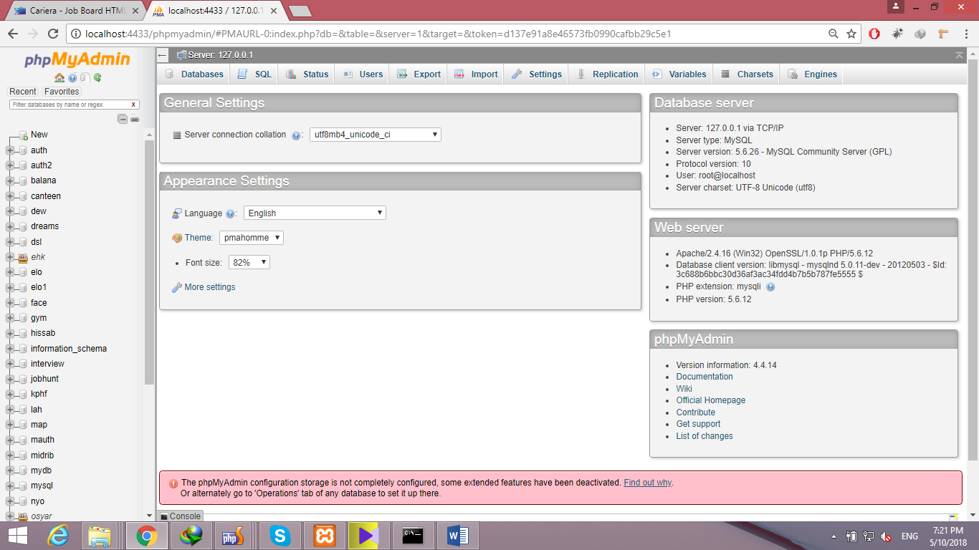

2. open jobhunt by just one click on it

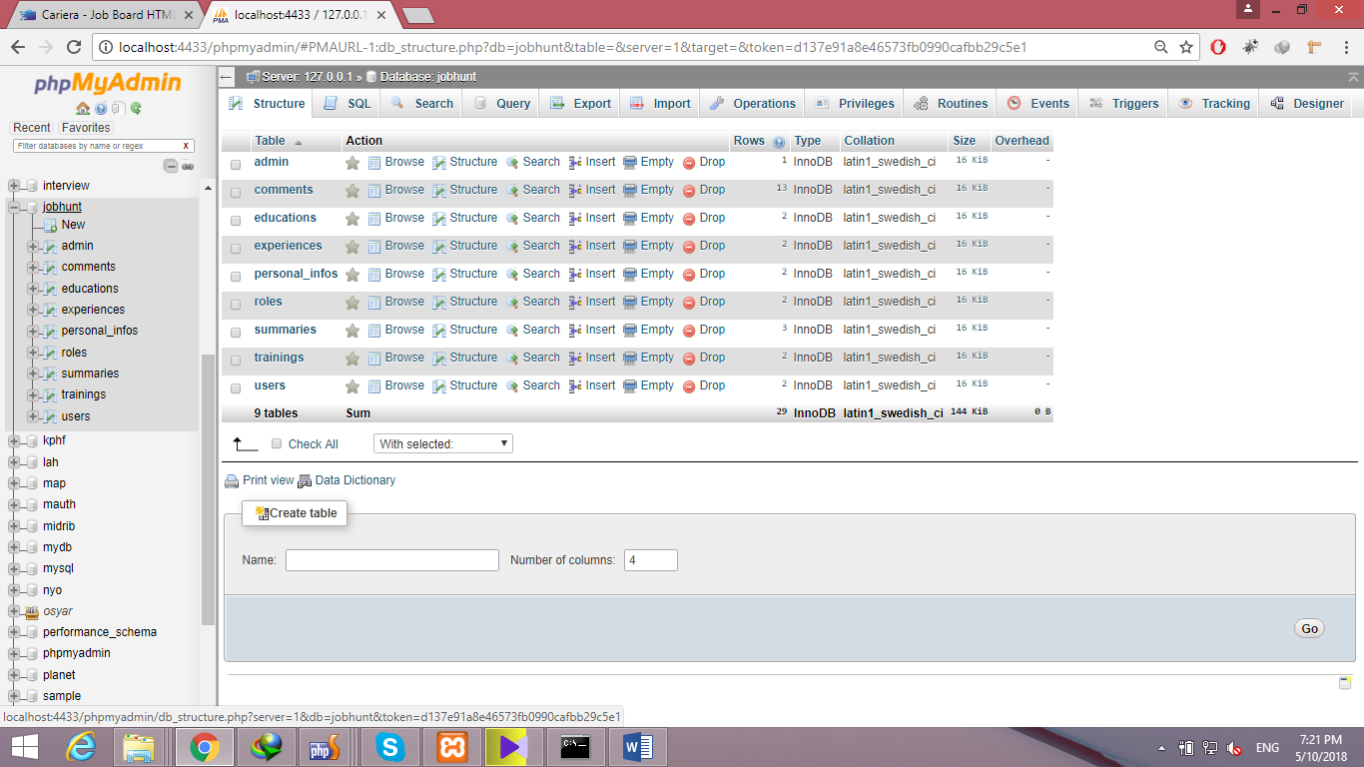

3. then click on operation

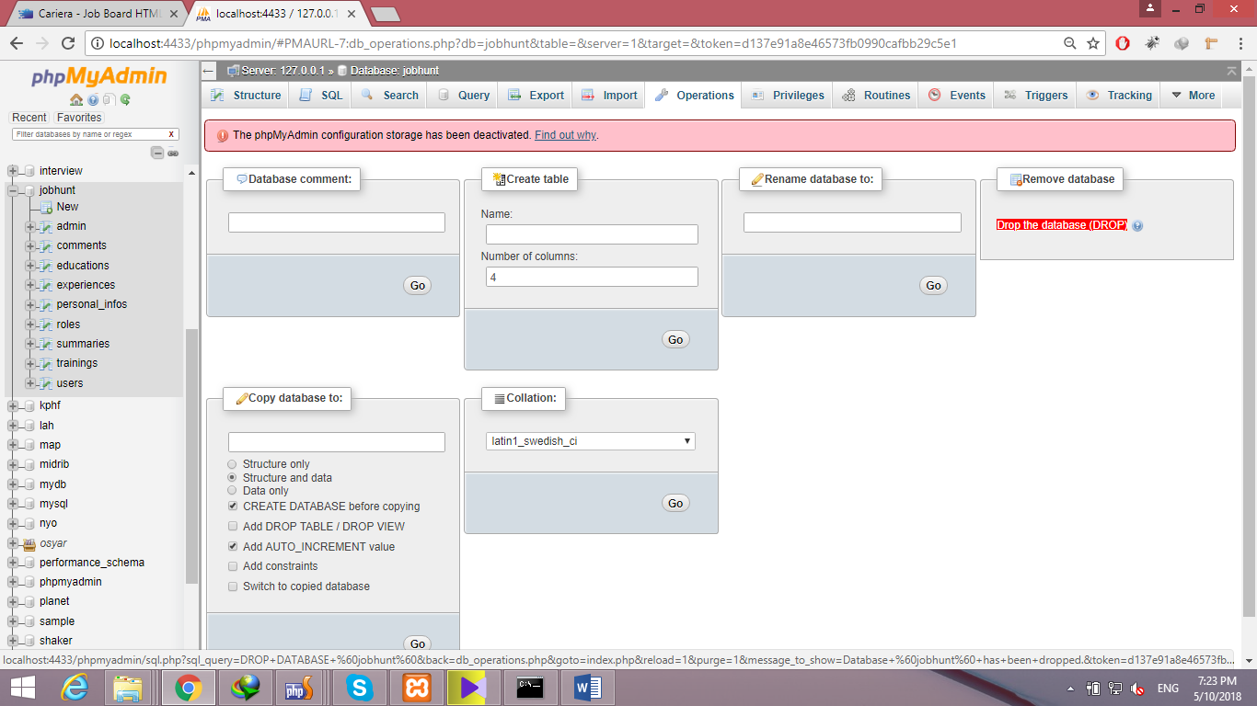

4. then click on drop the database .. database will be deleted ..

5. Now u need to create new database by click on new that is below phpmyadim logo

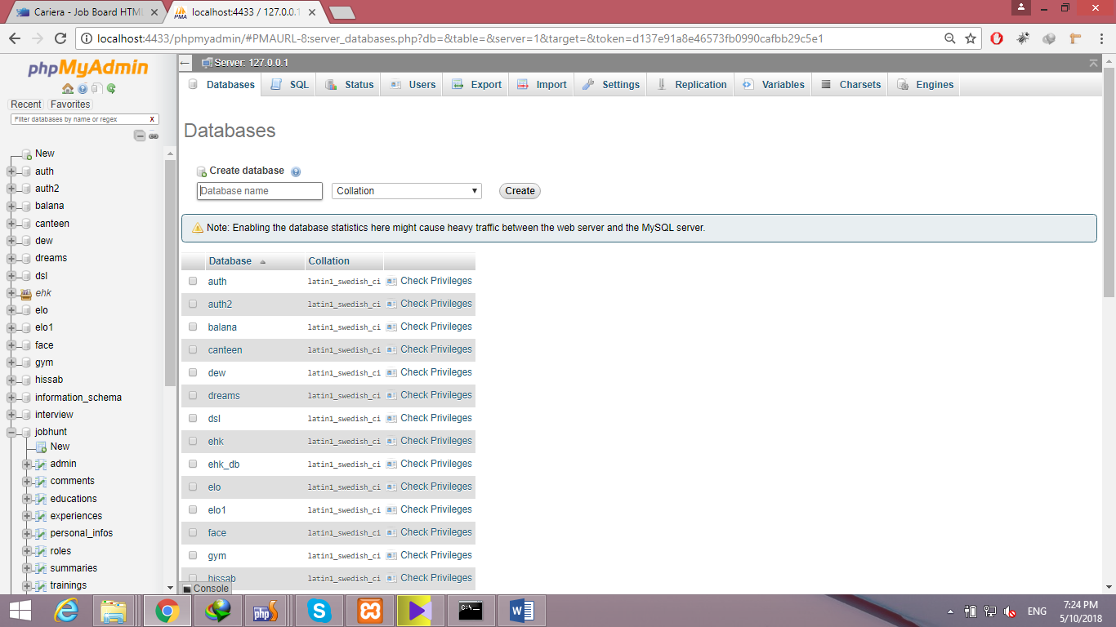

6. enter database name as jobhunt and press create

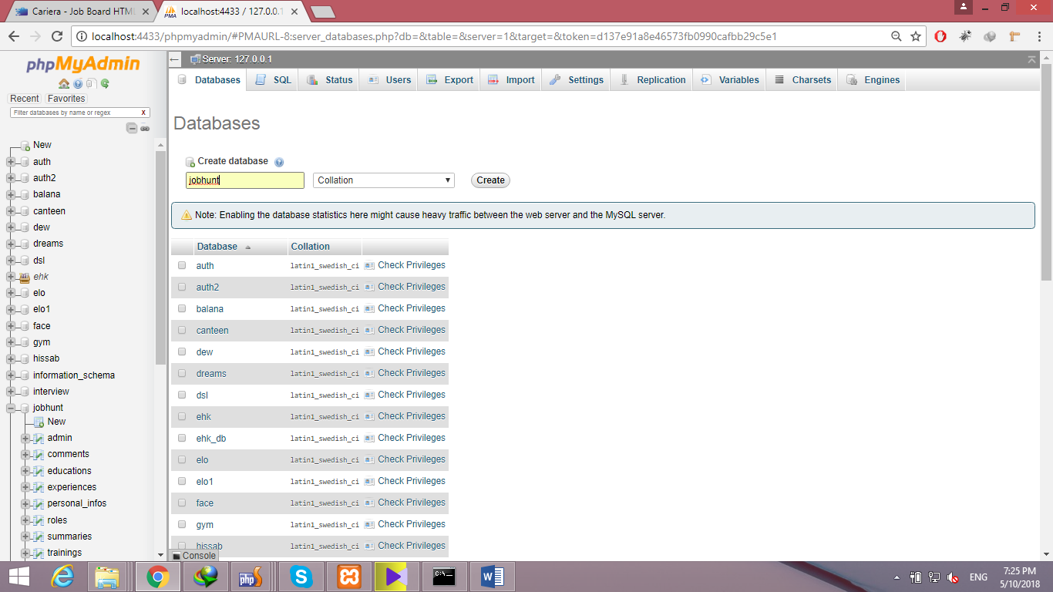

7. now click on jobhunt that is newly created database.

8. Then after single click on jobhunt u need to press import

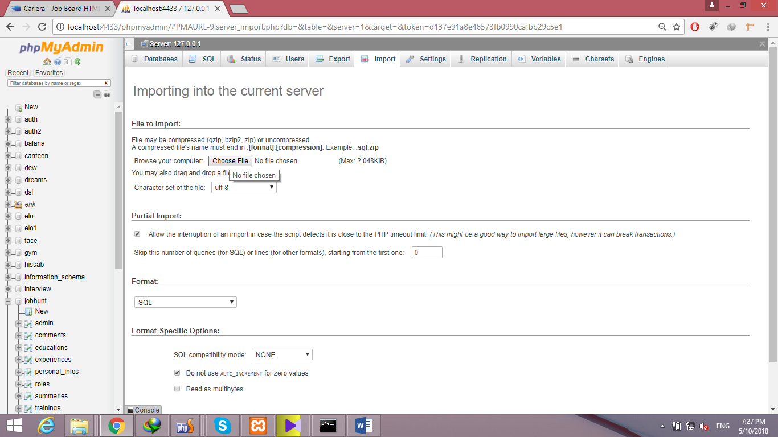

9. now u need to chose file that I will send named as jobhunt.sql

10. after chosing jobhunt.sql scroll down and press GO

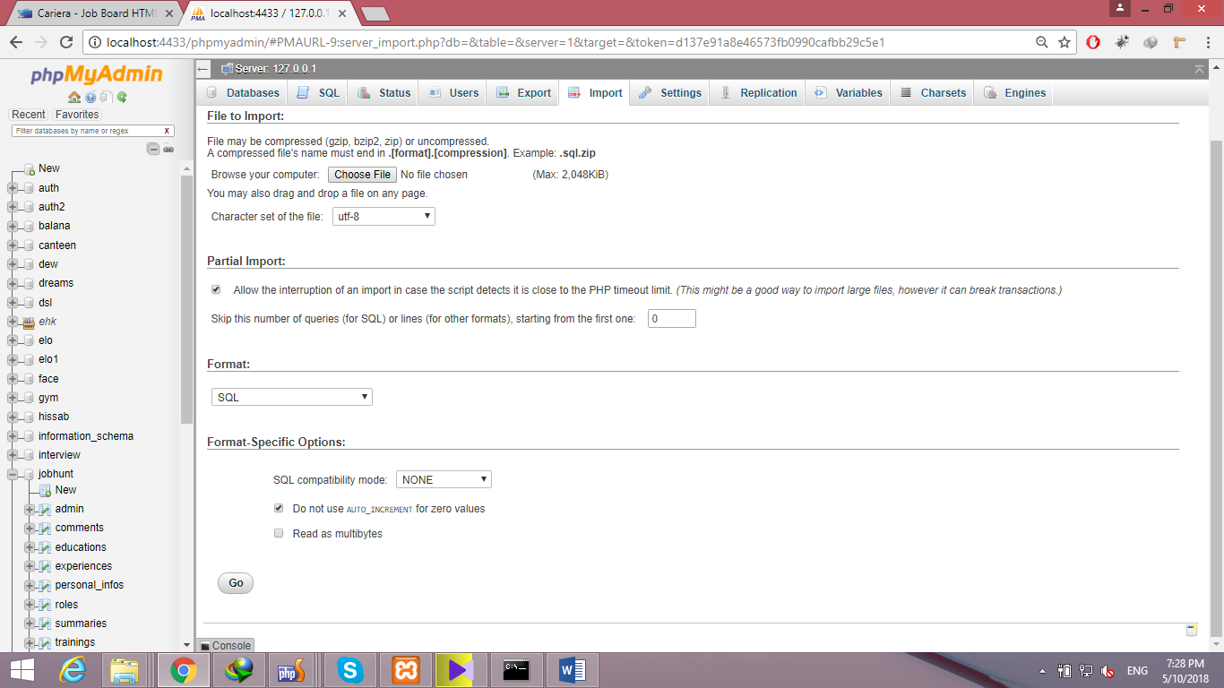

And that’s it